EV VS ICE PURCHASING PRICE

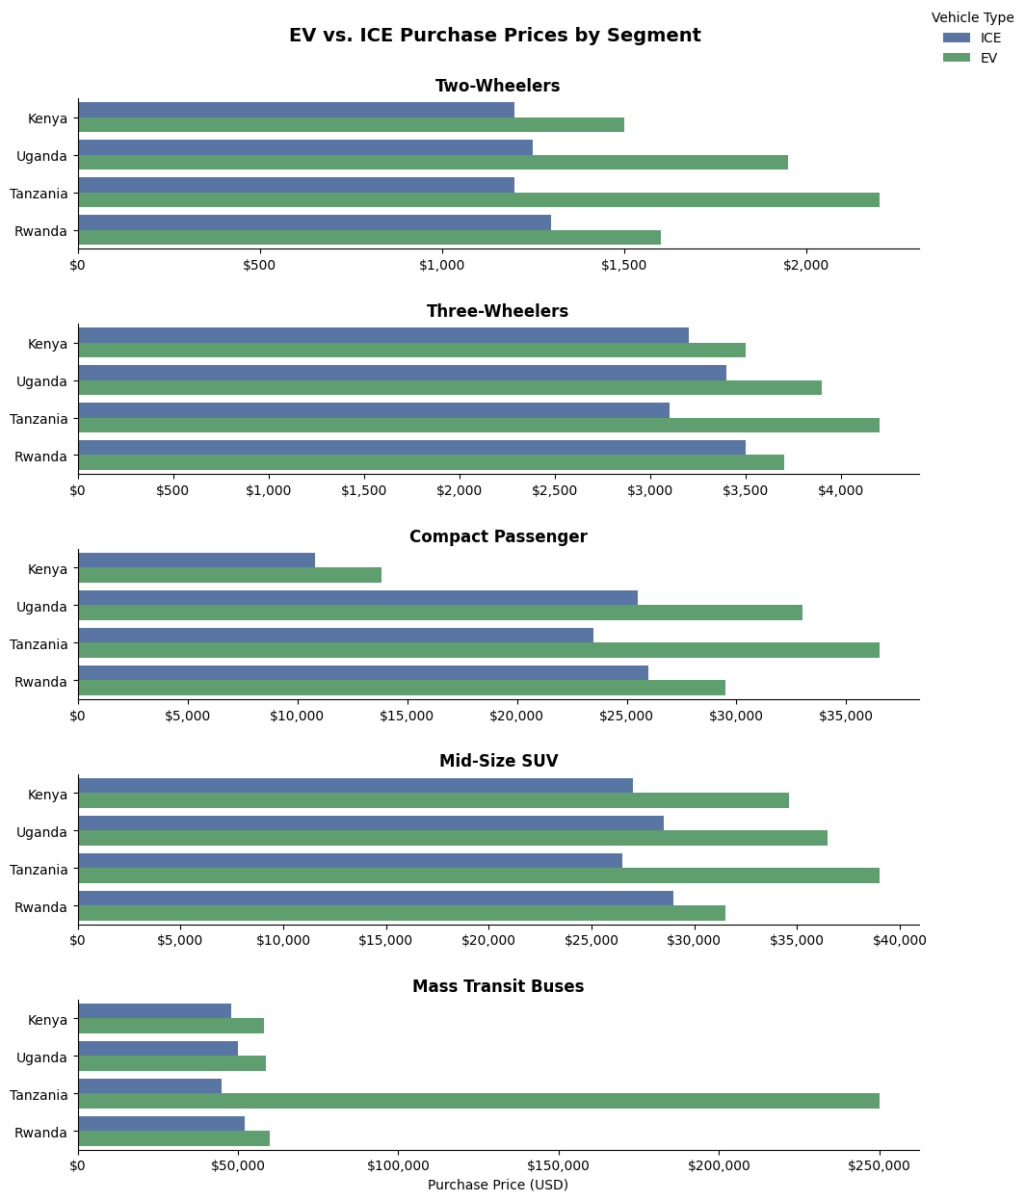

Core Analytical Observations:
Electric vehicles consistently cost more upfront than their fossil-fuel counterparts across East Africa, but the price gap depends heavily on the vehicle type and country. For motorbikes and three-wheelers, the price difference is remarkably small. This indicates that local assembly and battery-swapping setups are successfully keeping initial costs down for everyday drivers.
The story changes for passenger cars and SUVs, where regional tax differences create an uneven playing field. For example, a used petrol car is significantly cheaper to import into Kenya than into Uganda, Tanzania, or Rwanda. This makes it much harder for newer electric cars to compete in those markets.
Finally, electric buses show a massive pricing anomaly. While Kenya, Uganda, and Rwanda keep their electric bus prices relatively close to diesel alternatives, Tanzania’s electric bus price skyrockets to $250,000. This massive jump points to localized supply bottlenecks, different vehicle sizes, or unexempted import duties that need closer inspection.

Strategic Policy Insights for the EAC Region
- Create a Unified Tax Framework for Electric Vehicles: The wide price variation for cars across borders shows that uncoordinated national taxes and port fees are holding back a unified regional market. East African governments need to work together to align their customs duties and waive VAT on larger electric vehicles to make them affordable for regular consumers.
- Focus Heavily on Motorbikes and Commercial Fleets: Since two-wheelers and three-wheelers already have the narrowest price gaps, local policies should prioritize transitioning commercial fleets like boda-bodas. These segments can scale rapidly without needing heavy government subsidies, provided states invest in reliable, standardized battery-swapping networks.
- Standardize Electric Bus Procurement and Assembly: The extreme price spike for electric buses in certain countries shows the risk of importing technology on an ad-hoc basis. By pooling regional demand and setting shared standards for local vehicle assembly, East African nations can lower production costs and make clean public transit a viable reality.

